Welcome

to Santa Clarita URC
We are a Reformed church characterized by …
Sound Theology: We express our spiritual unity with Christians throughout the world by embracing the ecumenical creeds of the ancient church. As heirs of the Protestant Reformation, we further adhere to the Belgic Confession, the Heidelberg Catechism, and the Canons of Dort as faithful summaries of the Bible’s teaching.

God-Honoring Worship: We are called to worship God in an orderly manner, with reverence and awe. Our worship is in accordance with the regulative principle and patterned on the historic Reformed dialogical liturgy. The Psalms have the principal place in worship, along with God-honoring hymns that faithfully reflect the teaching of Scripture. The sacraments of baptism and the Lord’s Supper are administered as ordained by our Lord to confirm our faith in God’s covenant promises.

Christ-Centered Preaching: Our sermons are Christ-centered and expository, and special care is given to correctly distinguishing law and gospel. The law shows us our sin and misery and need of Christ. The gospel is the good news of our deliverance through Christ. As those who belong to him, the law in the hand of Christ teaches us how we ought to walk in thankful obedience.

Covenant Nurture: We believe that our children are included in the church. Parents, together with the church, have an obligation to raise their covenant children in the Lord, with the expectation that they will grow in maturity and make a public profession of faith in Christ and so be admitted to the Lord’s Table. Just as the Lord Jesus welcomed children, so we encourage the inclusion of children of all ages in our worship services.

Fellowship and Witness: We desire our church to have a culture of pastoral care, hospitality, and fellowship rooted in the love of Christ. We enjoy the fellowship of the body of Christ in our relationships with one another as a church family, even as we reach out to the community of Santa Clarita with the gospel of Christ.

Pastor: Rev. Dr. Lee Irons
pastor@santaclaritaurc.org

July 19, 2026

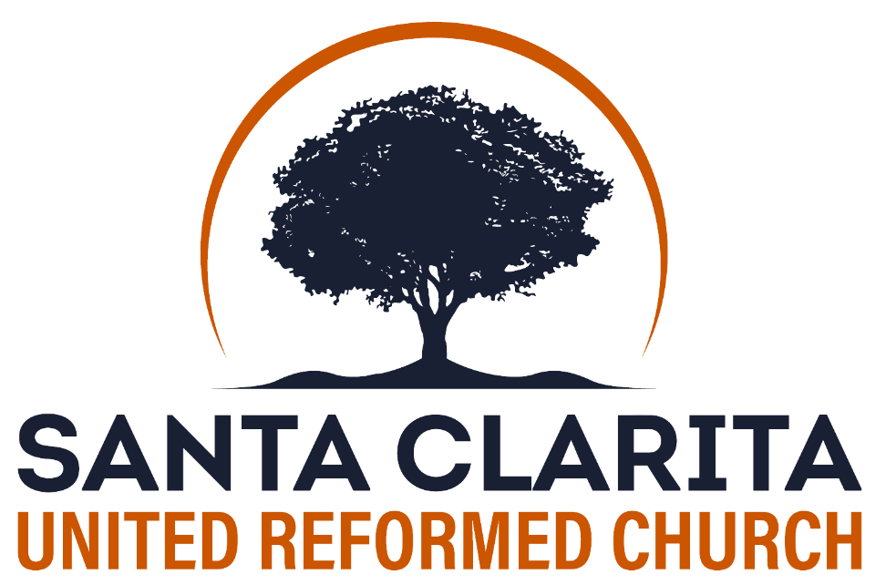

Sing praises to the Lord, O you his saints,
and give thanks to his holy name!
Lord’s Day Worship
10:00 am & 6:00 pm

26860 Seco Canyon Rd, Santa Clarita, CA
www.santaclaritaurc.org
Sunday – July 19, 2026
Morning Worship - 10:00 AM Rev. Dr. Lee Irons

Five minutes before worship: Please take a seat in the sanctuary and refrain from talking to prepare your heart for worship.

Silent Meditation
“I will sing to the Lord as long as I live; I will sing praise to my God while I have being. May my meditation be pleasing to him, for I rejoice in the Lord” (Psalm 104:33-34).

*Call To Worship

*Congregational Call & Response

Congregation, in whom is your confidence?

Our help is in the name of the Lord
Who made the heavens and the earth.

*God’s Greeting

*Song of Adoration
#146 (1-4) Praise the Lord! My Soul, O Praise Him!

*Prayer of Adoration

Call To Confession (God’s Law & Righteousness)

Prayer of Confession (in unison) – bulletin insert

Assurance of Pardon

*Song of Joy
#32A (1-5) What Blessedness Belongs to Him
(Song of the Month)

Revelation of God’s Will (Law as Service of Gratitude)

Congregational Prayer of Thanksgiving and Supplication

Offering: Regular

Reading and Preaching of God’s Word
Scripture Reading: Hebrews 6:4-12
Sermon: The Danger of Apostasy

Communion

We welcome to the Lord’s Table all who (1) are baptized in the name of the Triune God, (2) have made a public profession of faith in Christ, and (3) are active participants or members in good standing of a protestant church in which the gospel of Jesus Christ is preached and the two sacraments Christ instituted are administered under the oversight of elders who exercise church discipline.

*Song of Thanksgiving
#338 (1-4) When I Survey the Wondrous Cross

*Response of Faith: The Nicene Creed

*Benediction

*Doxology (unannounced)
#418 (4)

To God, the only wise, the one immortal King,
Let hallelujahs rise from every living thing;
Let all that breathe, on ev’ry coast,
Praise Father, Son, and Holy Ghost,
Praise Father, Son, and Holy Ghost.

Please join us for fellowship following the service

Sunday – July 19, 2026
Evening Worship - 6:00 PM Rev. Dr. Lee Irons

Five minutes before worship: Please take a seat in the sanctuary and refrain from talking to prepare your heart for worship.

Silent Meditation
“And I, when I am lifted up from the earth, will draw all people to myself” (John 12:32).

Pre-Service Songs: #280 (1-4), #353 (1,3,5), #372 (1-3)

*Call to Worship

*God’s Greeting

*Song of Adoration
#145D (1-6) God, My King, Thy Might Confessing

Congregational Prayer

The Lord’s Prayer

Our Father who is in Heaven, hallowed be your name.
Your kingdom come. Your will be done,
on earth as it is in heaven. Give us this day our daily bread,
and forgive us our debts, as we forgive our debtors.
And lead us not into temptation, but deliver us from evil.
For yours is the kingdom and the power and the glory forever.
Amen.

Offering

Song of Preparation
#9B (1-4) Wholehearted Thanksgiving

Reading and Preaching of God’s Word
Scripture Reading: John 1:29; 3:16; 1 John 2:2
Canons of Dort 2.3,5 (p. 904)
Sermon: Interpreting the “Universal Atonement” Passages

*Song of Reflection
#287 (1-5) Lift High the Cross

*Benediction

*Doxology (unannounced)
#113A (1-2)

Hallelujah! Raise, O raise
To the Lord our song of praise!
Praise, O servants of the Lord,
Praise the name of God the Lord.

From this time and evermore
Bless the name of God the Lord.
From the sunrise to its rest,
May the name of God be blest.

Evening Worship Notes Rev. Dr. Lee Irons

Interpreting the “Universal Atonement” Passages
Canons of Dort 2.3,5

Morning Worship Notes Rev. Dr. Lee Irons

The Danger of Apostasy
Hebrews 6:4-12

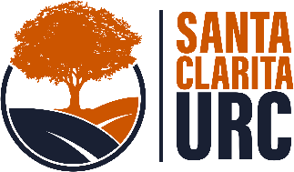
Announcements
Refreshments: Following the morning worship please join us for fellowship and refreshments. Visitors and guests are welcome!

Children: We welcome having
children of all ages in the worship service
with us. Parents of younger children are also free to utilize the unattended nursery down the hallway.

Christian Education Program: Sunday School / Catechism Classes are on summer break until the first Sunday after Labor Day.

Prayer Meeting: 1st Thursday, at 7:00 PM, at the church.

Women’s Bible Study: 2nd and 4th Wednesdays, at 6:30 PM.


Santa Clarita URC Offerings:

Checks should be made out to Santa Clarita United Reformed Church. You may also give online using the QR code.

Dr. Irons on vacation: Next Lord’s Day, July 26, Dr. Irons will be on vacation. The Rev. Chuck Tedrick, Dean of Students at Westminster Seminary California, will fill the pulpit in both the morning and the evening service.

URCNA SoCal Beach Day Fellowship: Saturday, August 1. For junior highers, high schoolers, college/young adults and their families. At Doheny State Beach. Picnic areas 8 & 9 reserved by Pasadena URC and the Ventura Reformed church plant. All the details here: tinyurl.com/urcbeachday

Church Plant Status: Santa Clarita URC is a mission work under the oversight and financial support of First URC Chino. Learn about the United Reformed Churches of North America at urcna.org.

Sermons available in video and audio format:
Video: youtube.com/@SantaClaritaURC
Audio: sermonaudio.com/broadcasters/santaclaritaurc

Follow us on social media: https://Linktr.ee/SantaClaritaURC

July 2026
Sun | Mon | Tue | Wed | Thu | Fri | Sat
28 | 29 | 30 | 1 | 2  Prayer Meeting  7:00 PM | 3 | 4
5 | 6 | 7  Chino Council | 8  Women’s Bible Study  6:30 PM | 9 | 10 | 11
12 | 13 | 14 | 15 | 16 | 17 | 18  SCURC  Council &  Consistory
19 | 20 | 21  Chino  Consistory | 22  Women’s Bible Study  6:30 PM | 23 | 24 | 25
26 | 27 | 28 | 29 | 30 | 31 | 1  URCNA SoCal Beach Day

